SYDNEY ESTONIAN PARENTS’ AND FRIENDS’ ASSOCIATION - ‘SÕRVE SÕBRAD’

Agenda
Leaders Meeting 2 - MINUTES
24.9.16 – 25.9.16
Pikkat’s Place 37 Grevillea Place Colo Vale

In attendance: Taimi Maidla, Marissa Apsey, Jana Moisa, Rhys Maidla, David Kass, Ella Ranniko, Gemma Provan, Josh Main, Marika Tults, Daisy, Conrad Zalewski, Rachel Matwisyk, Aaron Matwisyk, Karlene Matwisyk, Kayla Sandy
Skype/phone: Liisa Kuru, Tomas Kuru, Rein Kivivali, Siiri Iismaa
Saturday
- Meeting start 8:45am- Introductions – new leaders, new media, new excitement. Welcome all!
- Housekeeping and rules-
Leaders side rules:
- patient and respectful
- listen when people are talking
- no phones in meetings
- stay awake during meetings
- what is said in the leaders hut stays in the leaders hut
- last one up – clean up, lock up
- put away your own items
- vent in the right way
- support each other
- ALL to exercises
- Break when you can
- Together Everyone Achieves More

- Committee information
Fundraising
Trivia night very successful, not as good as last year due to silent auction items not being premium. Alcohol costs (bought too much for trivia) to balance out next events. Approx. +4500.00 raised
Next fundraiser = family picnic 23rd October at Bobbin Head – all leaders should be there to support & run games and promoting through social media beforehand

Fees
Need to pay fees by 30th November - $385 up to $423.50
NB; share the fees with people. Taimi to tell Imbi to tell everyone where the fees are coming from – as a result it fee rises and peoples concerns.

Others at Point Woolie
There will be others booked in at the Blue Village – keep an eye out for people roaming around without a wrist bands – please approach them and see if they are looking for someone at Sorve or are not a part of it – send them to Rachel for a wrist band if need be.
- Group bonding activity
- Favourite camp moment in one sentence
- Leadership Training – in groups
  - What skills does a leader need? Organised, patient, communication, enjoy yourself, languge barrier, time, respect, listening, team work, age appropriate, fairness, be their friend but not, know how to care for yourself, honesty, mad skillz brah, maturity, diplomacay, see the whole picture, be fun, assertive
  - How to communicate with different age groups
    - A Grupp – Keep calm, don’t talk down/don’t be condescending, no swearing, be explicit with instructions, age appropriate, leave E out of it, respectful, be their friend but not, assertive, fun, listen, guide not coach
    - B Grupp – Patience, no colourful language, age appropriate, simple, direct, assertive, be fun, clearer instructions, strong but with an open mind, positivity and happiness
    - C Grupp – Age appropriate, simple steps, modelling (monkey see monkey do), enthusiasm +++, caring nature, supportive, happy, gently, patient, variety of activities, flexible, no swearing, energetic, be open to parents
    - Parents – Politeness, respectful, proper, delegate, understanding, Estonian language, remember the children, diplomatic, no short abbreviations, be their friend but not, build relationships, no jargon, no gossip, confident, honest, explicit instructions, contextual
    - Juhid – Be clear & kind, patient and not snappy, having fun, joke around, be happy, offering to help/guidance, communication, don’t take jokes too far, positivity, no negative speaking, respect, age appropriate, be their friend but not, mentoring
A day in the life of a leader/ How to survive as leader
- Think of the bigger picture – camp is for the kids
- Rest when it is required
- Don’t be afraid to ask for help
- Water and Coffee
- Wake up before the whistle – not enjoyable being woken up by whistle, be prepared for kids early morning
- Don’t be hungover everyday
- Communicate – work together with small number of leaders
- Be 2 steps ahead of the day – plan and be prepared for you day (night before)
- Work with your partner Juhid to share duties
- Phones are a distraction, enjoy the holiday away from technology during day
- Be Happy
- Be Happy too

- AACS – Activity Aim Checklist Safety
AACS to be completed before Sōrve for the activities that you have been allocated to. Run through AACS form to practice it.
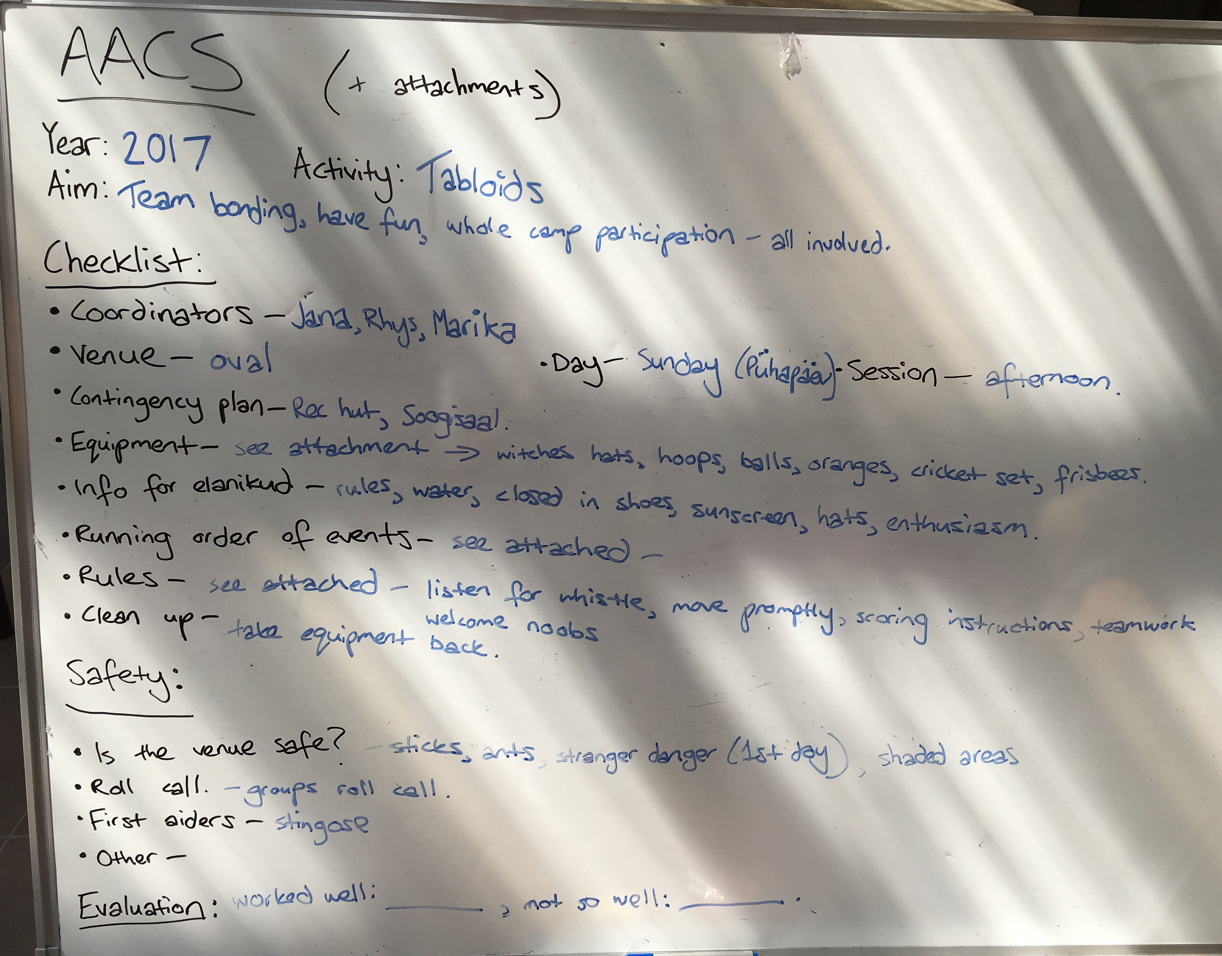
- Language with Sirje – Sirje to email juhid a list of functional sentences in a day to day at sorve. Marissa and Jana to create a double sided laminated sheet for juhid lanyards and inspection folders.
Commands in Estonian: we would go through a few simple commands that would work at camp and look at the difference between SINA and TEIE, so how to give a command to one person or many. For example:

1 person more than 1
tule siia! tulge siia! come here
ära tee (nii)! ärge tehke (nii)! don't do (that)
vaata! vaadake! look
mine! minge! go
too müts kaasa tooge müts(id) kaasa bring your hats etc
oota! oodake! wait

Other phrases and vocabulary that could be helpful. These were easy and short ones my kids understand despite not speaking Estonian much at all..

palun
aita mind! (for many: aidake mind)
Mis see on? - See on...
müts/kübar hat
veepudel water bottle
sokid
kingad
taskulamp torch
mäng
Lähme sööma! let's go eat
sööma! (come) eat
otse kohe straight away/ this minute
ruttu ruttu quick quick
appi! help!
Kus on .....? where is..?
Kuidas läheb? - hästi
ei/jah
miks? / miks mitte? why/why not?
Nii siis... so... / well then..
ujuma! (time) for a swim
lähme ujuma let's go for a swim
Kas sa oled valmis? are you ready?
Kas kõik on kohal? Is everyone present?
minu (oma)
sinu (oma)
Kus x on? - X on väljas/6ues/toas/sees/metsas/basseinis/söömas
Mina olen X, kes sina oled?
Mulle meeldib... I like...
Kes tahab''?/kes soovib..? Who wants..?

Pronunciation

perhaps a good idea to slowly pronounce all the above, even if known to many.
Points:

i and ii first one as in kIck second one as sEA (short vs long vowel sound)
a and aa first one short, second long sound of same vowel gum vs army
u and uu
o and oo
ä and ää
e and ee (as in veepudel, one long e and one short e in same word)
ö and öö
ü and üü

H is usually pronounced, even if in words like läHeb, läHme
the final letter of a word is always pronounced: like OskaR (not Osca), kübaR (not küba)

- Hut Orientation/Debrief
  - Hut Orientation
- All hut leaders and kids will get together to get to know each other
  - Introduction – name, where you’re from, what you’ve done throughout the year etc.
  - Ice breakers
  - Make sure new kids feel included and welcomed – possibly pair them up with someone to help them get to know everything and other kids
  - Try and find common ground
- Go through hut rules & camp rules and give everyone their handbooks
- Start hut decorating/bed making/poster for the door/streamers/write something for sosin
- Set the tone for your hut & set chores of everyone
  - Debrief
- Cry
- Warm and fuzzies
- Feedback on activities
  - What worked well, what you didn’t like, what could we do better
- Lunch
- Kasitoo with David – Leather bookmarks/bracelets
- Activity Schedule
  - Instructor Sports:
    - A- Rockclimbing, Sailing, archery, big swing (one hour only)
    - B- Rockclimbing, canoe, big swing, archery
  - Competitive sports:
    - Laptu, jalgpall, veepall, vōrkpall, newspaper hockey, rahvastepall, käsipall, käsitöö
  - Cultural activities:
    - Singing, dancing, language
- Bigger activity brainstorm (theme night, hut themes, big game, sosin, other, whole camp games)
  - Theme Nights: Prom, Space, food
  - Hut themes: Emotions. Avaloke skits = charades using the emotions/hut themes
  - Big game = Monopoly/Kayla
  - Whole Camp Games = Fresh – Taimi
  - Sosin – Heaps of ideas, to discuss tomorrow
  - Other: Idea of changing inspection and winning the boat to overall build up of points for good teamwork etc during camp. a lot of thoughts thrown around e.g.
    - If its not broken don’t fix it
    - How would the points work?
    - Kids are expected to do all of that anyway
    - Re-cleaning during swimming not early exercises
    - Too many awards at flag raising to bring in a new one
    - Add points to ulevatus points so the winners aren’t only cleaners etc
    - Imbi (and co) to make a plan of how they want it to work – potentially this idea could work – encourages the huts that aren’t very good at cleaning to keep trying because they can get points elsewhere. Have a list of ideas the huts can get points for (so it is controlled) and only have a couple people who can give the points (people willing to be aware and roam) – no other leaders know how points can be given so it builds up overall effort everywhere.
    - Action – Taimi to ask Imbi to make a plan for LM3
- Hut Themes/ Names
Decision = emotions Ideas: jealous, frustrated, scared, hangry, passionate, estatic, shocked, calm, alert, silly, lovestruck, bored, dopey, bashful, grumpy, tired, nervous, paranoid, blissful, incredulous
- Preferences
A Group Boys – Josh, David, Rhys, Aaron, Rein (Karlene)
B Group Boys – Rhys (oldest), Tomas, Marika
A Group Girls – Ella, Kayla, Karlene, Taimi, Daisy
B Group Girls – Kayla, Marika, Liisa, Gemma
Sports Leader: Karlene, Aaron, Ella
C-grupp: Committee
Supper games: Kayla, Marika, Karlene
Käsitöö: David
First Aiders: Karlene, Jana, Daisy, Josh, Ella, Rachel
Snacks: Kayla, Gemma
A group coordinators: Kayla, Rhys
B group coordinaors: No one
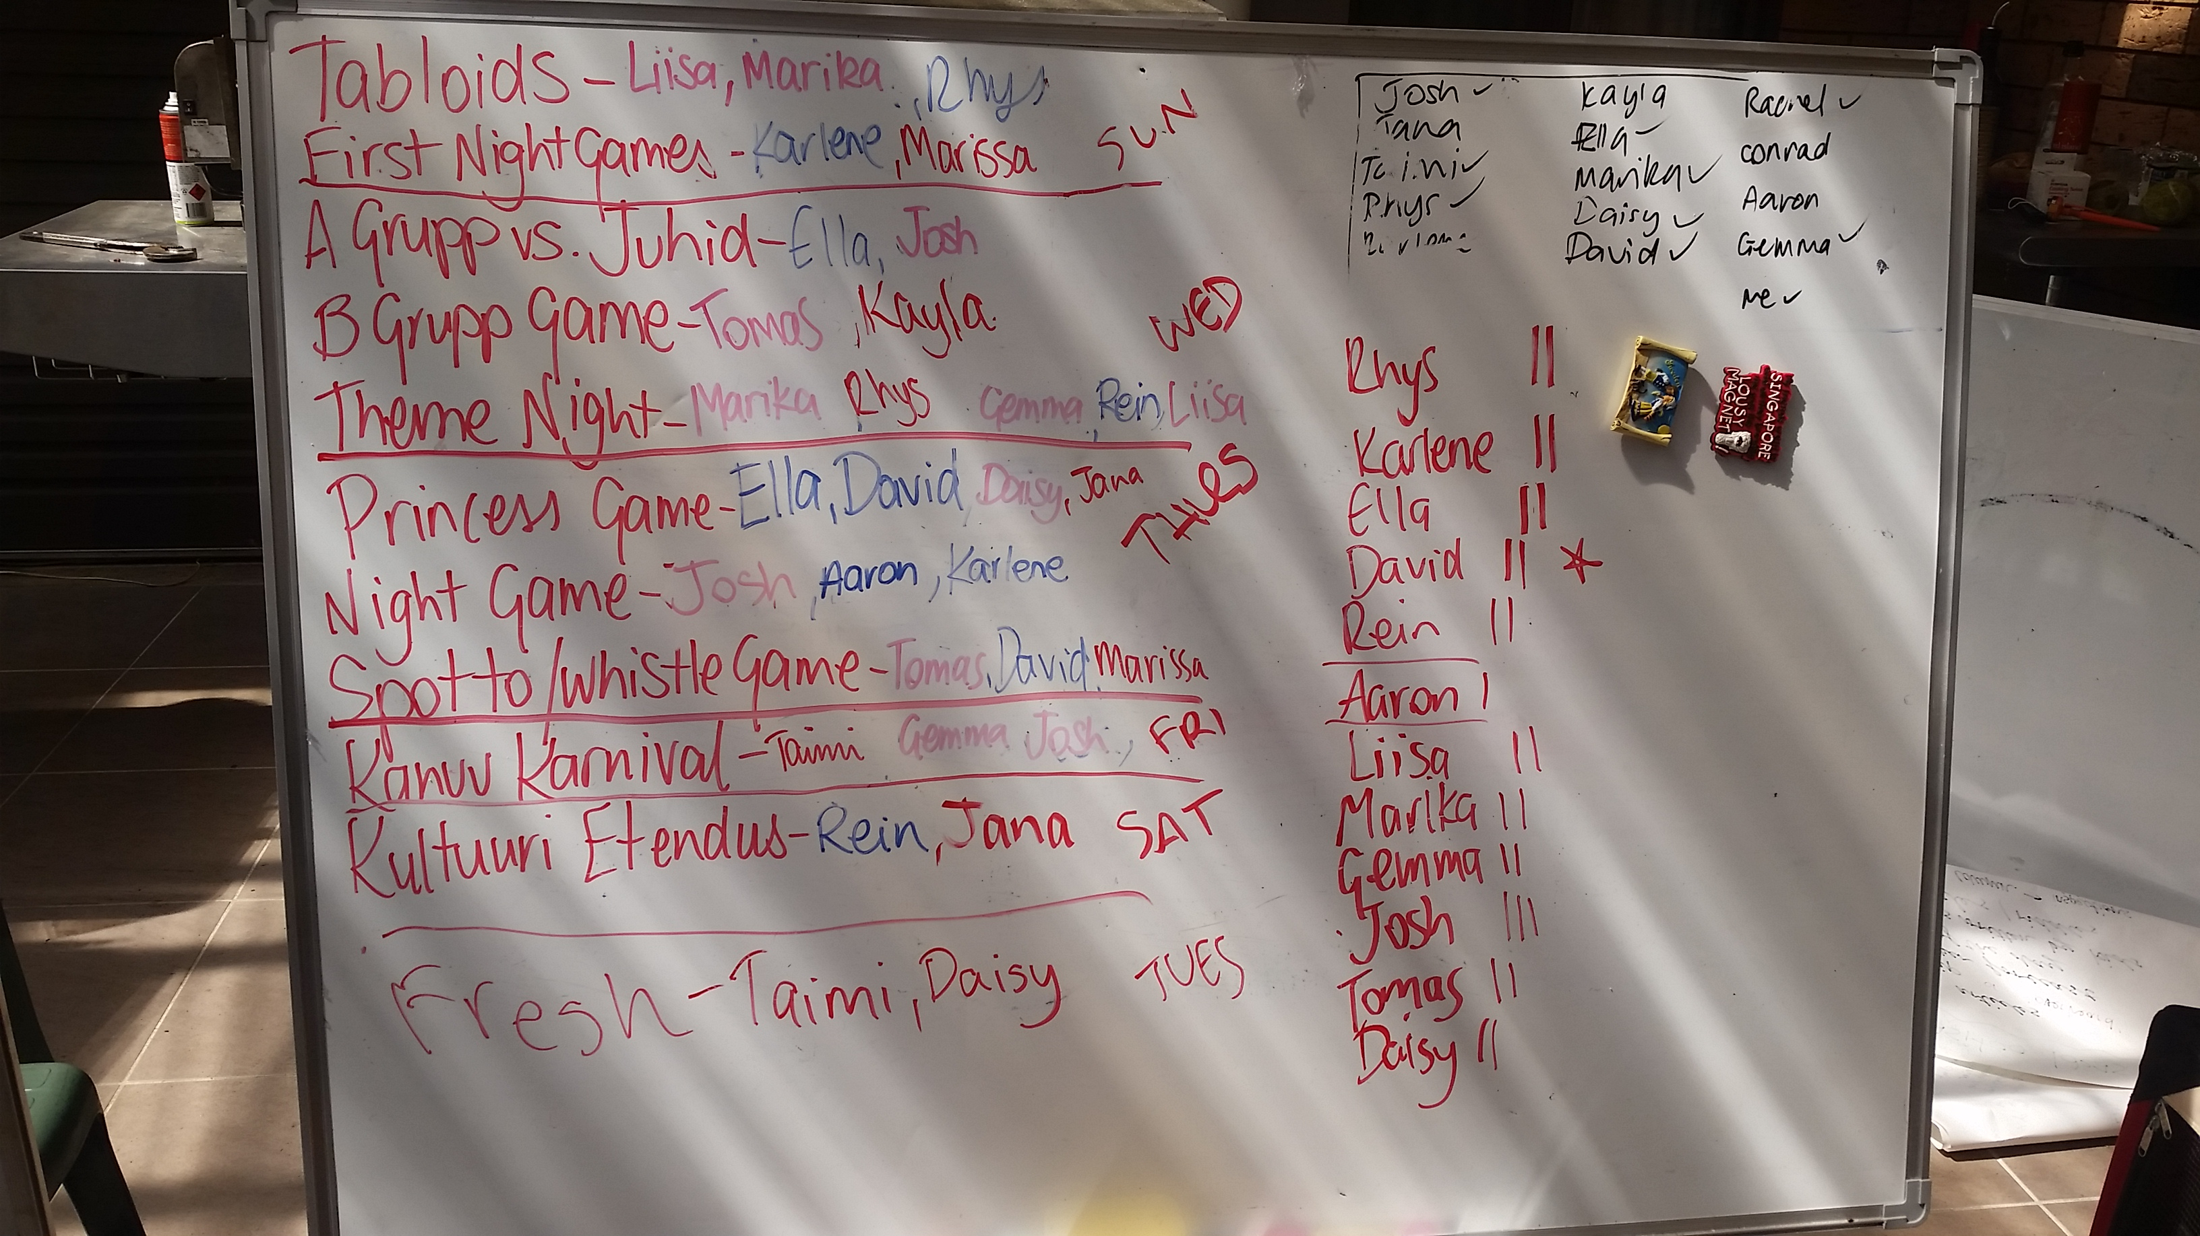
- Child protection/Working with Children Check
- never be alone with a child unless in an open space
- allocate boy and girl leader to activities when possible
- let the kids know where they can go during the night if they need a leader (e.g. where your tare is)

- Activity Schedule
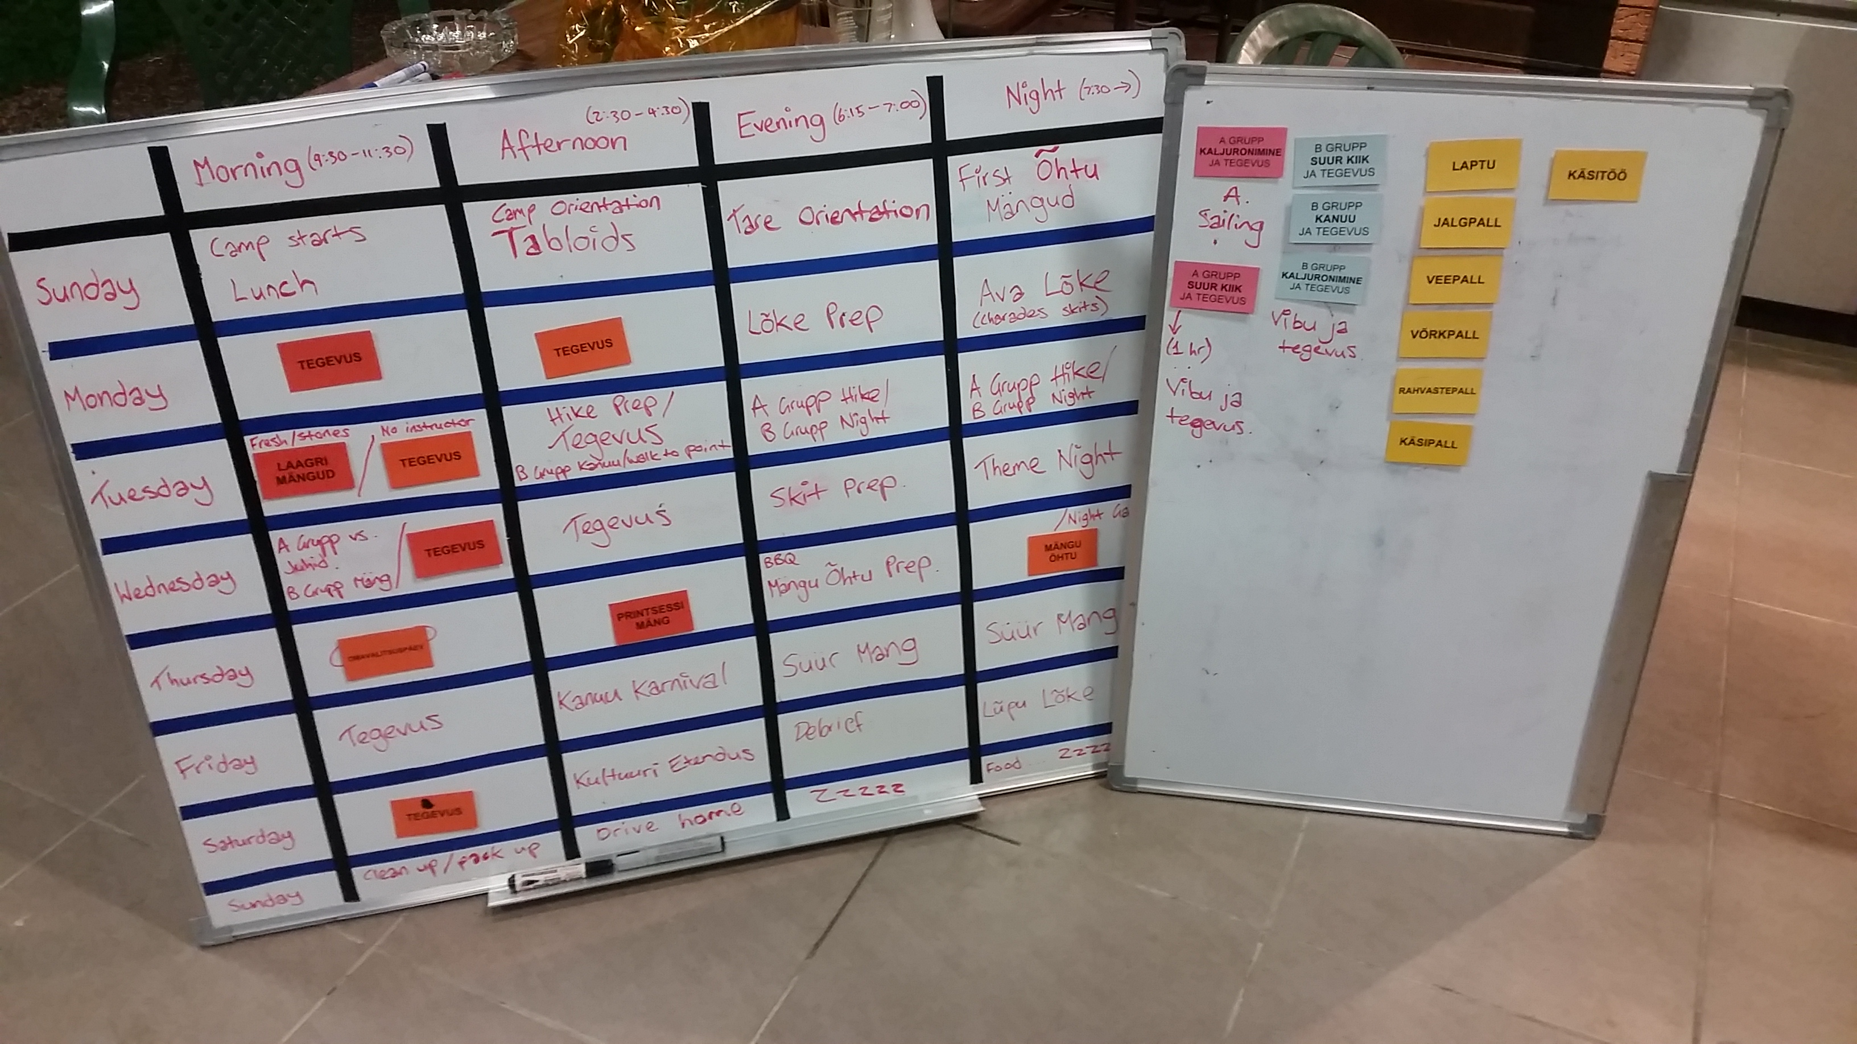

- Dinner/ Lõke
Sunday
- Wake up
- Breakfast
- Sosin/Media
- a lot of ideas noted down by Rachel and Conrad
- polaroid pictures for each day – make a string of them in soogisal
- make a poster of more recent photos to put up with other posters in soogisal (Karlene)

- Big Game
Monopoly – collecting properties. Kayla to email everyone with information.
- EOI scenarios
- Other Business
- Phones added to policy – get a basket for activities – kids put phones in baskets during activity time and get it returned. What is the plan if kids don’t put there phone in the basket and thy get caught out?
- Daisy to check with her work to see if first aid items and sunscreen etc can be donated
- Leader Special T-shirts – Marika, Daisy, Liisa, Tomas, Aaron, Gemma (Taimi to collect shirts from Marz, Karla, Danae, Andrew, Martin, Toomas, Arne, Hendrik, Kati – and whoever else). To be worm first day and visitors weekend.
- Leader shirts – blue (or grey!) – Blue on main days.

- Next meeting
  - LM3 – 4th November Friday Night – Eesti Maja – apologies Gemma, Kayla (maybe Aaron and Karlene).
  - LM4 – 4th December Sunday – TBA where – very important to attend. (AACS forms to be completed by now).

- Close of meeting

- Lunch
- Pack up and go home

A TYPICAL DAY FOR A JUHT

6.50 Kommandant wakes up Korrapidajad (KP)
Have your own alarm set (or one per tare)
6.55 Whistle for wake up for elanikud and juhid
Make sure all elanikud are dressed and at exercises. Be on time! If you’re on exercises, prepare the night before.
7.05 Exercises followed by Swimming (optional) out of pool by 7.15
Hut juhid take turns in going to exercises and helping elanikud. All juhid at all exercises
7.30 Pesemine ja Tarede Korsitamine (Showering and cleaning huts)
Both leaders helping to clean hut, ensure kids clean their huts and themselves. Good time to have a shower yourself.
7.50 Hommikusöök (Breakfast)
Arrive on time. Juhid to go in after elanikud unless sitting with tare for meal. Spordijuht will hand out small activity schedules to all juhid.
Elanikud serve elanikud, Juhid to serve juhid (rostered, wear enclosed shoes).
Ensure that elanikud eat and clean up tables
After breakfast return to tare and run through ‘inspection/flag raising checklist’ (B-Grupp)
8.45 Ülevaatus (Inspection)
Juhid get ready for the day – equipment, water, sunscreen, hat, proper shoes, juhid shirt, etc
Make sure tared take baskets to lippu heiskamine
9.15 Lippu hesikamine (Flag Raising)
Arrive on time. Make sure elanikud arrive on time
Line kids up and hand out song sheets
After lipuheiskamine make sure kids take off Sõrve särk and put in baskets.

9.30 Tegevus (Activities)
Get elanikud together in their sport group areas quickly
Go to activities
11.30 Ujumine (Swimming)
Lifeguards to the pool- need fluoro vest, walkie-taikie, hat, etc
Elanikud can swim when the first-aider and 1 other juht is present. Spread out around pool, continually scan the water.
Other juhid to take responsibility of the elanikud on verandahs.
12.30 Lõunasöök (Lunch)
Arrive on time. Juhid to go in after elanikud. Juhid daily lunch date. Spordijuht will hand out small activity schedules to all juhid.
Elanikud serve elanikud, Juhid to serve juhid (rostered, wear enclosed shoes).
Ensure that elanikud eat and clean up tables.
1.15 Lõunarahu (Rest Period)
Make sure elanikud are on their verandahs or common areas (TBC). B-Grupp heads on own pillows and quiet time.
Juhid to share supervision with other juhid on same verandah
2.20 Activity Prep
Whistle blown. Get ready for afternoon activities.
Make sure elanikud have hats, sunscreen, water, proper shoes, swimming costumes, etc
2.30 Tegevus (Activities)
Get elanikud together in their sport group areas quickly
Go to activities
4.30 Ujumine (Swimming)
Lifeguards to the pool- need fluoro vest, walkie-taikie, hat, etc
Elanikud can swim when the first-aider and 1 other juht is present. Spread out around pool, continually scan the water.
Other juhid to take responsibility of the elanikud on verandahs.
5.30 Õhtusöök (Dinner)
Arrive on time. Juhid to go in after elanikud.
Elanikud serve elanikud, Juhid to serve juhid (rostered, wear enclosed shoes).
Ensure that elanikud eat and clean up tables.
6.15 Öösel tegevus ettevalmistus (Night Activity preparation)
Juhid to help tare / prepare for night activities
Make sure kids have aeroguard, proper shoes, torches, etc
7.30 Lõke/Öösel tegevus (Campfire/Night Activity)
Listen for the whistle, arrive on time.
Participate and encourage.
9.15 Piim ja ringmängud (Supper and Games)
Participate and encourage.
9.45 B group juhid to take elanikud down to tared
10.00 Lights out for B Group
Help elanikud to get ready for bed
10.15 A group juhid to take elanikud down to tared
10.30 Lights out for A Group
Ensure elanikud get ready for bed
10.35 Leaders’ evening meeting
Participate and encourage
Snacks, drinks, etc.Destroy all evidence before going to bed
- Sosin ideas: Who wore it better? Fun facts, Estonian recipes (that have been cooked at camp), Jokes, Tare interviews, Photos, Sudoku, Flashback comparisons, # hastags, TBT, MCM, WCW (wtf?), Poems, Haiku, Quiz (Sõrve prizes), What’s hot, and what’s not, Scavenger hunt, “Dear Kati” confessions, Lost property items for sale, Tips & Tricks to win sport/inspection, Profile tare (e.g. top 10 facts on witches and Tallinn), Room for Rent, Classifieds, “Looking for love”, Quote of the day
- B Group Night: Scavenger hunt, Chalk chase, Small scale spoto on oval, Games (What’s the time Mr wolf, Bull rush, Stuck in the mud, Crocodile, Fruit salad, bump) – gauge from first day games to see what works well and can be doubled up and still be fun, face painting, Lõke, Damper, “Birthday party” night instead of lõke – pass the parcel, pin the tail, decorate cupcakes, eat donuts off clothesline, bob for apples (yes!, seconded, let’s change up b-group night! – thirded!!, agreed. A group will take these!)
- A Group Night: Point, Hike, Can do own cooking @ BBQ, Prom night, date/restaurant night, carnival/games night (too many games! – yes!), Catch&Kiss, SLAVE GAME!, Sleep over?, Disco/dance night, Scare (new one?) Movie night (after hike – yes please!), Slip ‘n’ Slide, A group walk to lilypond and scare on way back (or not? Needs to be very well planned to be effective)
- Theme night: Under the sea, Vacations/Holidays/Destinations (racist?)/Around the World, Night @ the movies (have to make movie trailers), Visit to the Museum (artworks, sculpture, painting, light installation), Science (lab, test tubes, periodic table, elements [give each tare an element?]. Think Big Bang Theory), Back to school () Dancing with the Stars (line dancing, tap dancing, hip hop, ballet, ballroom, jazz, salsa, contemporary, folk dancing, belly dancing, break dancing, waltz, cha cha, tango, polka), Star Wars! (won’t engage the whole audience?! Do kids even know what it is? Yes – there’s a new movie coming out!), The Voice, Space, Fairy Tales, History (throughout the ages – everyone gets a different era, ), Horror, Cities around the world, Zoo, Circus/Carnival, Pre-School theme, Kitchen (cooking show), A Current Affair
- Lõke: New songs (make sure juhid have warning so they can practice songs), Flea, Going on a Bear Hunt, History/Trivia of camp, „A Day in the Life of a juht“ skit for kids, Bring back the Hakka, Juhid skits ( Hendrik The Phresh Prince of Bel Air), Leidsin Pähkla, C-Group and Parent involvement, Tare hüüd, Traditions – bringing and taking the flame, Blanket skit (for juhid), How to win v. how to lose inspection, Viking Song (condensed version), Pre-assigned skit ideas, Camp items for props as skits, Decorate Lõle plats with fairy lights, Old/New Songs
- Käsitöö: Jewellery (beads – we have lots, scooby-doos, children’s jewellery makers are sick – research them!, Bakey beads, Candles, Painting, Photoframes, Scrapbooking, Bushcraft, Lino printing, Yarn/Wool – French knitting, wrap mason jars (have heaps in trailer), make decorative vases, candle holders, pen holders, Metal Pressing, Fragranced massage oils, Calico bags, Plaster making and painting, Badge making, Pottery (make sure it doesn’t need kilning), Leather craft, Candle making, Coloured Pencil Jewllery, Papier Mâché, Tie dye, Wood Burning.
- C – Grupp: Marissa I’ll give you piece of paper ‘cause it’s FULL of ideas!
- Whole Camp Activities:
  - First day: Slave games, Fruit salad, Bump, Banana Game (maybe save for A-Group night?), Pulse (Hendy), Footy Drill (Alex’s game), Cat & Mouse, Duck Duck Goose, Wink Murder, Stuc in the Mud, Scarecrow tip tiggy, 40/40 home (one person “it” at a tree), cops and robbers
  - First night: Mount/Dismount, Captain’s coming, Rob the Nest, Musical Knees, Musical Hoops, Islands, Bandaid, Fruit/Balloon passing, Blindfolded feeding games, Drunk Irish, Hungry Hippos, Appropriate music – prepared playlist
  - Last day “Laagri Mängud”: Scavenger hunt (10 rocks, feather, stick, cicada shell, Kati’s middle name (She doesn’t have one), Item (e.g. lanyard) from juht, red cup.), Photo game (handstand on veranda, planking on jetty, rahvatants @ lõke, pool sign with whole team, selfie with laagri juht, tere tulemast sign, someone in bin, wombat hole, 3 wise monkeys @ specific location, with 5 leaders together, with C-Grouper (every C-grouper has to be in a photo), human pyramid, Handstand on play equipment, cross dressing, pretend to play tennis, with a Sport & Rec person, with the Boat

