Leaders Meeting Weekend Saturday 27th September
Point Wolstoncroft

Meeting started: 9:20am

Present: Marissa P, Alex R, Kayla S, Rhys M, Ella R, Andrew K, Indrek J, Martin V, David K, Karlene M, Jana M, Karla J, Kati K, Ron, Pille

Apologies: Arvi L, Taimi M, Krista M, Arne R, Tomas k, Danae P, Maare-Liis K, Toni L, Kris V.

1. Ice breaker
- Who are we?
- How long have we been involved in Sõrve?
- What do you want to get out of this weekend?
- Who is the most famous person you’ve met?

2. Committee Information:
Update: relinquished roles- to Kaili
Aim: blueprint of running camp-creation of pass on doc- mid November deadline. To include: roles and responsibilities. To use as checklist.
- new web page- changes immediately- contact martin
- fundraising- trivia night and Eurovision- $6000
- Moving towards registrations- October/November exclusive access=120 people, encouragement for new members/returning- selling camp. New marketing- combined Australian & Estonian
- Sunday= new people
- Finance: pricing- $23000, discount last year $8000 down to $15000 we need 120 if not need to cover. Adult $740 child $500 leader $490 $250 discount. Over 120 people=discount. Incentive: brining new people getting discount. Still have first timers discount adults $690 children $400 free for under 2's. Age: still to be decided.
- Liit: sponsoring lady from Estonia- available to teach Estonian at camp committee will organise schedule
- Kieran- music workshop last Friday and Saturday at camp
- Tomorrow- will need help

3. House Rules
- No phones
- Listening
- Don’t talk over people- no side conversations
- Have fun!
- Respect other people’s opinions
- Ask questions
- Offline: 3 “offlines” moving onto the next conversation topic.
Money: Friday 25 sun 23.33 food: $15 pp TOTAL: $64 give moola before dinner

4. Juhtkond setup:
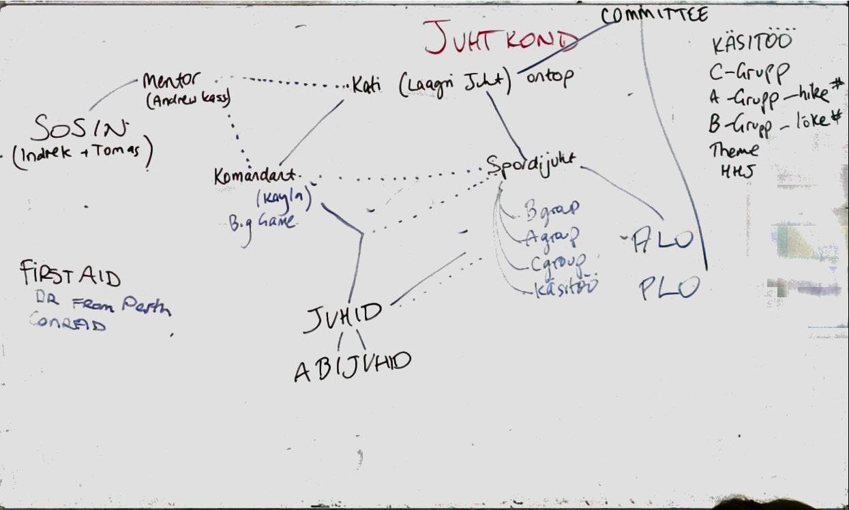

5. Activity schedule
Attached at the end.

Theme Night | Danae Rhys Alex, Ella
1st Night Games (in the afternoon) | Abijuhid (David, Rhys, Ella, Maare-Liis, Arne) + Martin/Karlene
Hut Orientation + Ava Lõke | Kati
Halli Hundi Jooks | Toni Kris Maare-Liis
Prom Night  B-Grupp Night | A-Grupp Leaders: Kayla  B-Grupp leaders: Danae
A Grupp v. Leaders  B Grupp | Alex, Arne (Arvi)  Instructor Sports – Sports leader
Mole Game | Jana David Taimi
Jeopardy / Spoto | Marissa, Rhys, Andrew
Play Offs | Sports Leader Arne
Cultural Afternoon | Ella, Kayla
Omavalitsusõhtu | A grupp leaders (Kris)
Kultuur | Ella, Kayla
Sosin | Tomas Indrek (Andrew)

SPORTS | INSTRUCTOR | CULTURAL
Rahvastepall | Vibu | Rahvatants
Korvpall | Kaljuronimine | Cooking
Võrkpall | Suur Kiik | Laulmine (Kieran)
Bucketball | Kanuu | Language classes (Ms Pesti)
Kickball | Purjetamine
Floorball | Wombat hole (combine with Vibu?)
 | High Ropes

6. Hut allocations

These are based on the assumption that we have 10 huts. This will change depending on numbers.

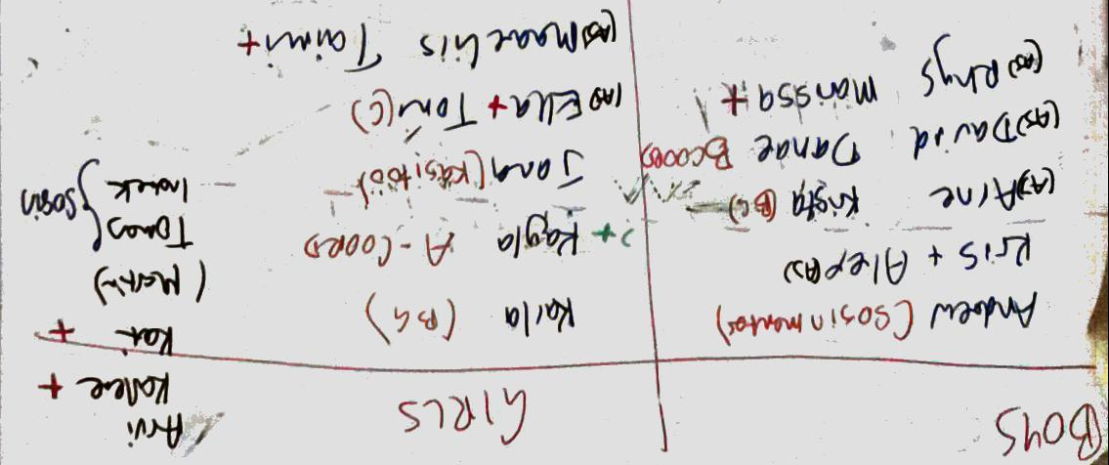

7. Hut themes:
- objects can work into skits
- gardening tools
- things you can use at camp- insect repellent, deodorant, swimming costume, bow and arrow, sleeping bag, hats,
Objects used at Sõrve |  | Mythical Creatures |  | Estonian Foods
Insect repellent |  | Unicorn | Phoenix | Pirukas | Kapsarullid
Decorations |  | Zombie | Pegasus | Hapukapsas | Sült
Swimmers | Sõrve Särk | Goblin | Leprechaun | Soola ja Pippar | Dill
Bow & Arrow |  | Fairies | Yeti | Pipparkoogid | Hapukoor
Sleeping Bag |  | Elves | Giant | Heeringas | Pikkpoiss
Hat |  | Dragon | Dwarf | Must leib | Saku
Sunscreen |  | Vampire |  | Hapukurk
Shampoo |  | Werewolf |  | Rosolje
Torch |  | Centaur |  | Kringel
Water Bottle |  | Vampire |  | Vana Tallinn
Socks |  | Dragon |  | Vodka
Water Shoes |  | Mermaid |  | Mulgikapsas
Running Shoes |  | Ogre |  | Verevorst

8. Tomorrow’s program

    - Morning activities(tabloids/first night games)>bbq>afternoon activities
    - AACS

9. Big Game
Leah, Krista and Karla are organising.
Any ideas for: Vanaisa who can pretend to be Disney – Hr Kuru? Andrew?
Checkpoint suggestions: Lion King (hyena), Cindarella, Dumbo (circus), Little Mermaid, cold room, Aladdin (lamp), 101 Dalmatians (spots), pirates, bobbing for apples, mirror, mad hatter, tea sets, hats, Mr Potato Head, Monsters Inc, Wall-E, Ratatouie

Krista and Karla to have huts and activity responsibilities after big game.
Email to come shortly with list and prop needs

10. First Aid
Ella, Kati, Karlene

SÕRVE ACTIVITY SCHEDULE 2015
 |  | BREAKFAST 7:50PM |  | LUNCH 12:30PM |  | DINNER 5:30PM
DAY/DATE |  | MORNING 9:30-11:30 |  | AFTERNOON 2:30-4:30 |  | EVENING 6:15-7:00PM |  | NIGHT 7:30PM
SUNDAY |  | Saabumine 1pm |  |  |  | Whole Camp Orientation |  | Ava Lõke
4-Jan |  | NO LUNCH |  | 1st Night games afternoon |  | Hut Orientation
MONDAY
5-Jan |  | Tegevus |  | Tegevus |  | Theme Prep |  | Theme
TUESDAY |  |  |  |  | A | Prom Night | A | Prom Night (OVÕ prep)
6-Jan |  | Halli Hundi Jooks |  | Tegevus | B | Hike/Games | B | B-Grupp Lõke
WEDNESDAY
7-Jan |  | Tegevus |  | Tegevus |  | Omavalitsusõhtu |  | Omavalitsusõhtu
THURSDAY
8-Jan |  | Tegevus |  | Tegevus |  | Suur Mäng |  | Suur Mäng
FRIDAY |  |  |  | A-Grupp v. Leaders
9-Jan |  | Mole Game |  | B Grupp Instructor Sports |  | Jeopardy |  | Spoto/Whistle
SATURDAY |  |  |  |  | ALL | Lipu Langetamine | ALL | Lõpu Lõke
10-Jan |  | Play Offs |  | Kultuuri Etendus |  | Camp Photo
SUNDAY
11-Jan |  | Eat |  | Clean |  | Drive

